Want more races??
Try the Carroll County Triple Crown 5K Series!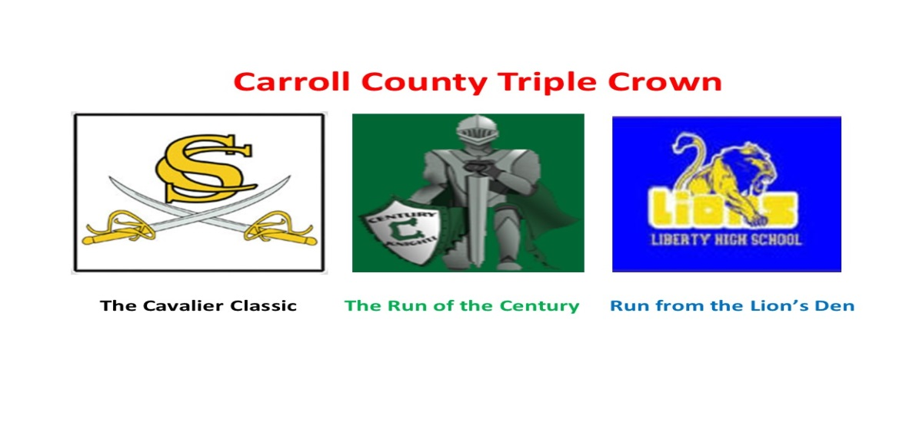
Total of 3 races - all 5K distances
Run all three races and receive a CCTC Medal.
Medal awarded at the last race.

October 21, 2017 - South Carroll High School Trail Run
November 18, 2017 - Century High School Road Race
December 2, 2017 - Liberty High School Trail Run

Registration Fee $60 (includes all 3 races) - No discounts - Mail in registration form or register on Active.com

------------------------------------To register by mail, cut & mail this portion of registration form----------------------------------------------------

Name: _____________________________________________ Age on race day: _______ (Circle): Male Female

Address:_______________________________________________ Email: ________________________________
________________________________________________

Shirt Size: (circle one) S M L XL

Waiver and release: I recognize that participation in this activity may involve certain hazards. I understand that I should not participate unless medically able. I assume all risks associated with this event, including but not limited to falls, contact with other participants, effects of weather and road and traffic conditions, all such risks being known and appreciated by me. Having read this waiver and knowing these facts and in consideration of your accepting my entry, I , for myself and anyone entitled to act on my behalf, waive and release all sponsors and hosts and their representatives and successors from any claim of liability arising from any involvement in this activity. The Americans with Disabilities Act applies to the Carroll County Government and its programs, services, activities, and facilities. Anyone requiring an auxiliary aid or service for effective communication or who has a complaint should contact The Department of Citizen Services, 410.386.3600 or 1.888.302.8978 or MD Relay 7-1-1/1.800.735.2258 as soon as possible but no later than 72 hours before the scheduled event.

Signature of Applicant: _____________________________________ Date: ______________

Signature of parent (if under 18): _____________________________________ Date: ______________.

Make checks payable to: Eldersburg Rogue Runners
Mail to: ERR-CCTC Series, PO Box 1726, Eldersburg, MD 21784

