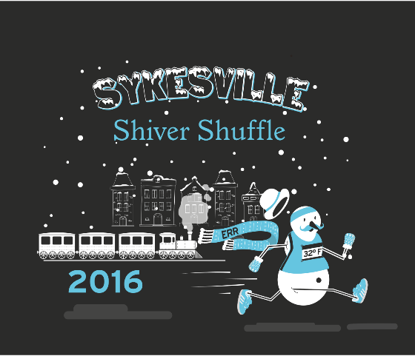
Registration:
Name: _____________________________ Address: ________________________________________________
City: ________________________ Zip: ____________ Phone: ___________________________________
Email: ____________________________________Date of Birth____________ (Circle one) Male Female

Shirt size: Female LG, _____
MED______, LG_______, XL, ______
WAIVER OF LIABILITY: Participant understands that he/she is subject to the school and council rules of conduct and sportsmanship. The undersigned acknowledges that neither the Freedom Area Recreation Council, the Eldersburg Rogue Runners nor Tri Sport Junction provide any registrant medical or hospitalization insurance whatsoever, and hereby waives any and all claims against the Freedom Area Recreation Council, the Carroll County Department of Recreation and Parks, Eldersburg Rogue Runners, Tri Sport Junction, or any other person affiliated with these entities and sponsors for injuries sustained while watching or participating in this event or traveling to and from event. I also agree that photographs taken of my child or me while participating in this activity may be used for publicity purposes. I am the legal guardian of the athlete listed above and have read the above waiver of liability

Signature and Date_________________________________________________________
Register after January 1, 2016
Fee $35 per person
ERR Member $30
Mail to: Eldersburg Rogue Runners PO Box 1726 Eldersburg MD 2178
Or Drop off at : Tri Sport Junction 7568 B Main St, Sykesville MD 21784

