**The Eldersburg Rogue Runners**

**Justify the Pie 5K**

Packet Pick up 1-6 PM Nov 21st at Tri Sport Junction

Race Day registration and packet pick 7:30 – 8:30 AM

**Registration:**

**Name: _____________________________ Address: ________________________________________________**

**City: ________________________ Zip: ____________ Phone: ___________________________________**

**Email: ____________________________________Age as of day of race_____ (Circle one) Male Female**

**Check one**

**Timed 5K $5­­­­_________**

**Timed 5K and Race T shirt $15 ________**

**Untimed no shirt FREE _______**

**Untimed with shirt $10________**

**IF applicable**

**Shirt size: unisex X Small _______Small_____ MED______, LG_______, XL, ______2XL,____**

**Youth Med_______ Youth Large_________**

**Mail form and check to Eldersburg Rogue Runners , PO Box 1726, Eldersburg MD 21784**

**WAIVER OF LIABILITY: The undersigned acknowledges that neither the Freedom Area Recreation Council, the Eldersburg Rogue Runners, Tri Sport Junction , nor Blackbird CrossFit provide any registrant medical or hospitalization insurance whatsoever, and hereby waives any and all claims against the Freedom Area Recreation Council, the Carroll County Department of Recreation and Parks, Eldersburg Rogue Runners, Tri Sport Junction, Blackbird CrossFit or any other person affiliated with these entities and sponsors for injuries sustained while watching or participating in this event or traveling to and from event. I also agree that photographs taken me while participating in this activity may be used for publicity purposes. I have read the above waiver of liability**

**Signature and Date_________________________________________________________**

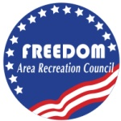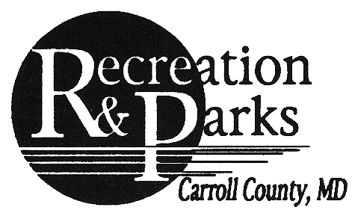**The Americans with Disabilities Act applies to the Carroll County Government and its programs, services, activities, and facilities. Anyone requiring an auxiliary aid or service for effective communication or who has a complaint should contact The Department of Citizen Services,**[**410.386.3600**](tel:410.386.3600)**or**[**1.888.302.8978**](tel:1.888.302.8978)**or MD Relay 7-1-1/**[**1.800.735.2258**](tel:1.800.735.2258)**as soon as possible but no later than 72 hours before the scheduled event.**