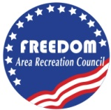
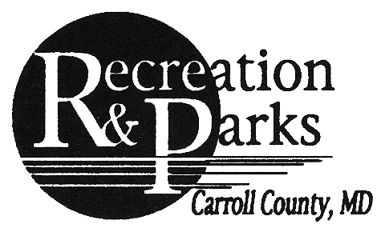
Registration Form
Liberty Reservoir Expedition
Name ______________________________________
Birthdate_____________________ Age __
Email____________________________________
Phone #_______________________________
Emergency Contact Name and Ph# _________________________________
Running Hat $20
ERR Members $10
WAIVER OF LIABILITY: Participant understands that he/she is subject to the school and council rules of conduct and sportsmanship. The undersigned acknowledges that neither the Freedom Area Recreation Council nor the Eldersburg Rogue Runners provide any registrant medical or hospitalization insurance whatsoever, and hereby waives any and all claims against the Freedom Area Recreation Council, the Carroll County Department of Recreation and Parks, Eldersburg Rogue Runners, or any other person affiliated with these entities and sponsors for injuries sustained while watching or participating in this event or traveling to and from event. I also agree that photographs taken of my child or me while participating in this activity may be used for publicity purposes.
I am over 18 or I am the legal guardian of the athlete listed above and have read the above waiver of liability

The Americans with Disabilities Act applies to the Carroll County Government and its programs, services, activities, and facilities. Anyone requiring an auxiliary aid or service for effective communication or who has a complaint should contact Madeline M. Morey, The Americans with Disabilities Act Coordinator, 410.386.3800,1.888.302.8978, MD Relay 7-1-1/1.800.735.2258 or email mmorey@ccg.carr.org as soon as possible but no later than 72 hours before the scheduled event.

Signature and Date______________________________________________________________

