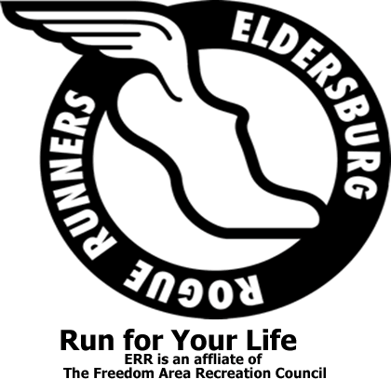
Labor Day Rogue Race
10K, 5K and 1 Mile Fun Run/Walk
September 3, 2018
Liberty High School
10K & 5K 8:30 a.m. (timed)
1 Mile Fun Run 9:15 a.m. (untimed)

ERR Member $20 until 7/31 $25 after 7/31
Non Member $25 until 7/31 $30 after 7/31
1 Mile Fun Run $15
Adult free with paying child under 10 years of age
Mail in Registration form or Register on ItsYourRace.com
Packet pick-up Saturday 9/1 from 1-4pm and Sunday 9/2 from 11-2 pm at
Tri Sport Junction
7568 B Main Street Sykesville

Registration Form
Must be post marked by August 30, 2018
Name ______________________________________y
Birthdate___________________Age (by race day) _____
T Shirt size circle one (Unisex): SM MD LG XL 2XL
Youth MD Youth LG
(postmarked by August 13th 2018 for shirt guarantee)
Email____________________________________
Phone #_______________________________
Emergency Contact Name and Phone: ______________________

WAIVER OF LIABILITY: Participant understands that he/she is subject to the school and council rules of conduct and sportsmanship. The undersigned acknowledges that neither the Freedom Area Recreation Council nor the Eldersburg Rogue Runners provide any registrant medical or hospitalization insurance whatsoever, and hereby waives any and all claims against the Freedom Area Recreation Council, the Carroll County Department of Recreation and Parks, Eldersburg Rogue Runners, or any other person affiliated with these entities and sponsors for injuries sustained while watching or participating in this event or traveling to and from event. I also agree that photographs taken of my child or me while participating in this activity may be used for publicity purposes.
I am over 18 or I am the legal guardian of the athlete listed above and have read the above waiver of liability
Signature and Date______________________________________________________________
Mail to : ERR Labor Day Race, PO Box 1726, Eldersburg MD 21784