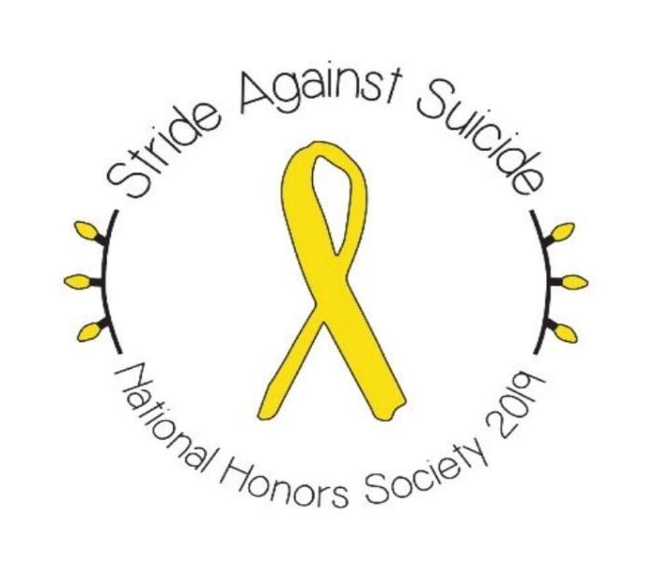

Liberty High School National Honor Society
Stride Against Suicide
5K run and walk 9:00 am Saturday December 7th, 2019
100, Raincliffe Rd, Sykesville, MD 21784
National Suicide Prevention Lifeline: 1-800-273-8255

Cost: $20 for pre-registration. Race-Day registration cost: $25
Online Registration available at https://www.active.com/sykesville-md/running/distance-running-races/stride-against-suicide-5k-2019?int=72-3-A3 until Wednesday December 4th at 11:00 pm (search for Stride Against Suicide)
Or visit www.errun.org to download the registration form (return form to Tri Sport Junction)
Pre-race packet pick-up, Friday December 6th 6-8 pm at Tri Sport Junction, 7568 B Main St., Sykesville
Wear yellow to spread more awareness!

The race will benefit a suicide prevention organization. Questions? Email: libertylionsnhs@gmail.com
___________________________________________________________________________________________
Mail and remit payment to: Eldersburg Rogue Runners, c/o SAS19, PO Box 1726, Eldersburg, MD 21784.

Name_________________________________________Address: ________________________________________
City________________________Zip:_____________Phone: ____________________________________________
Email: _________________________________________ Age on race day: ________ Male Female

Signature of registrant and Date: _________________________________________________________
Signature of parent (if under 18) and Date: __________________________________________________
WAIVER OF LIABILITY: Participant understands that he/she is subject to the school and council rules of conduct and sportsmanship. The undersigned acknowledges that neither the Freedom Area Recreation Council nor the Eldersburg Rogue Runners provide any registrant medical or hospitalization insurance whatsoever, and hereby waives any and all claims against the Freedom Area Recreation Council, the Carroll County Department of Recreation and Parks, Eldersburg Rogue Runners, or any other person affiliated with these entities and sponsors for injuries sustained while watching or participating in this event or traveling to and from event. I also agree that photographs taken of my child or me while participating in this activity may be used for publicity purposes. I am the legal guardian of the athlete listed above and have read the above waiver of liability. The Americans with Disabilities Act applies to the Carroll County Government and its programs, services, activities, and facilities. Anyone requiring an auxiliary aid or service for effective communication or who has a complaint should contact The Department of Citizen Services, 410.386.3600 or 1.888.302.8978 or MD Relay 7‐1‐1/1.800.735.2258 as soon as possible but no later than 72 hours before the scheduled event.

