

**South Carroll High School Athletic Boosters and Cross Country Team Present the**

**7th Annual Cavalier Classic**

**5K Trail Run & 1 Mile Walk - 9:00am - Saturday, October 21, 2017**

**Stadium at South Carroll HS**

**1300 W. Old Liberty Rd**

**Sykesville, MD 21784**

* Pre-register!! Guaranteed t-shirt to registrations received by October 7th. Late or same-day registration, t-shirt not guaranteed.
* Cost: $25 ($23 for ERR Members) for pre-registration. Race-Day registration cost: $35
* Online Registration available at [www.Active.com](http://www.Active.com/), search for Cavalier Classic
* Pre-race packet pick-up, Friday, Oct 20th, 3-7pm at Tri Sport Junction at 7568 B Main St., Sykesville
* Race-Day registration and packet pickup begins at 7:30am at SCHS Stadium

**Proceeds benefit the SCHS Athletic Boosters & the Jessica E. Belknap Memorial Scholarship fund.**

The SCHS Athletic Boosters is a 501(c) (3) non-profit organization that promotes and supports all athletic programs at SCHS. The Jessica E. Belknap Memorial Scholarship is awarded to a student in the Veterinary Science program at SCHS each year.

**Contact Information:** If you have questions, please email the Boosters at: [cavclassic@schsathleticboosters.org](mailto:cavclassic@schsathleticboosters.org)

------------------------------------ To register by mail, cut & mail this portion of registration form ----------------------------------------------------

Name: _____________________________________________ Age on race day: _______ (Circle): Male Female

Address:______________________________________________­­­­­­­­­­­­­­­­­­­­_ Email: ________________________________

________________________________________________

**Shirt Size:** (circle one) S M L XL **Race:** (check one) 5K run ____ 1 mile walk ____ **Donation only:** ______

Waiver and release: I recognize that participation in this activity may involve certain hazards. I understand that I should not participate unless medically able. I assume all risks associated with this event, including but not limited to falls, contact with other participants, effects of weather and road and traffic conditions, all such risks being known and appreciated by me. Having read this waiver and knowing these facts and in consideration of your accepting my entry, I , for myself and anyone entitled to act on my behalf, waive and release SCHS, all sponsors and hosts and their representatives and successors from any claim of liability arising from any involvement in this activity. The Americans with Disabilities Act applies to the Carroll County Government and its programs, services, activities, and facilities. Anyone requiring an auxiliary aid or service for effective communication or who has a complaint should contact The Department of Citizen Services, [410.386.3600](tel:410.386.3600) or [1.888.302.8978](tel:1.888.302.8978) or MD Relay 7-1-1/[1.800.735.2258](tel:1.800.735.2258) as soon as possible but no later than 72 hours before the scheduled event.

Signature of Applicant: _____________________________________ Date: ______________

Signature of parent (if under 18): _____________________________________ Date: ______________

***Make checks payable to: South Carroll HS Athletic Boosters***

***Mail to: SCHS Athletic Boosters c/o Cavalier Classic, 1300 W. Old Liberty Road, Sykesville, MD 21784***

**Want more races??**

**Try the Carroll County Triple Crown 5K Series!**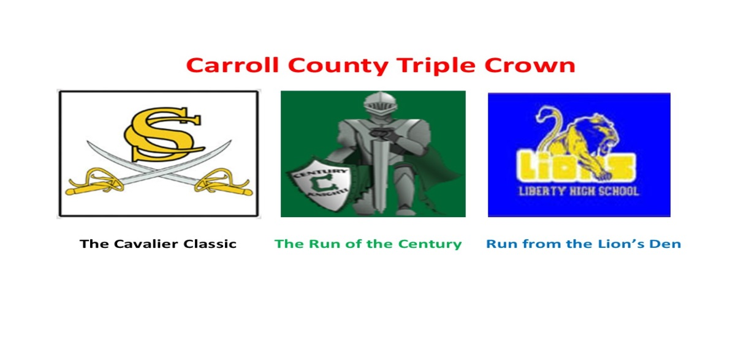

**Total of 3 races - all 5K distances**

**Run all three races and receive a CCTC Medal.**

**Medal awarded at the last race.**

October 21, 2017 - South Carroll High School Trail Run

November 18, 2017 - Century High School Road Race

December 2, 2017 - Liberty High School Trail Run

Registration Fee $60 (includes all 3 races) - No discounts - Mail in registration form or register on Active.com

------------------------------------To register by mail, cut & mail this portion of registration form----------------------------------------------------

Name: _____________________________________________ Age on race day: _______ (Circle): Male Female

Address:______________________________________________­­­­­­­­­­­­­­­­­­­­_ Email: ________________________________

________________________________________________

**Shirt Size:** (circle one) S M L XL

Waiver and release: I recognize that participation in this activity may involve certain hazards. I understand that I should not participate unless medically able. I assume all risks associated with this event, including but not limited to falls, contact with other participants, effects of weather and road and traffic conditions, all such risks being known and appreciated by me. Having read this waiver and knowing these facts and in consideration of your accepting my entry, I , for myself and anyone entitled to act on my behalf, waive and release all sponsors and hosts and their representatives and successors from any claim of liability arising from any involvement in this activity. The Americans with Disabilities Act applies to the Carroll County Government and its programs, services, activities, and facilities. Anyone requiring an auxiliary aid or service for effective communication or who has a complaint should contact The Department of Citizen Services, [410.386.3600](tel:410.386.3600) or [1.888.302.8978](tel:1.888.302.8978) or MD Relay 7-1-1/[1.800.735.2258](tel:1.800.735.2258) as soon as possible but no later than 72 hours before the scheduled event.

Signature of Applicant: _____________________________________ Date: ______________

Signature of parent (if under 18): _____________________________________ Date: ______________.

***Make checks payable to: Eldersburg Rogue Runners***

***Mail to: ERR-CCTC Series, PO Box 1726, Eldersburg, MD 21784***